Task on IAM

1: Create one IAM user and assign EC2 and S3 full access roles.
Task 1 — IAM User + EC2 & S3 Full Access
IAM User: DevopsAdmin
|
├── AmazonEC2FullAccess
|
└── AmazonS3FullAccessreate:
The goal is to understand User → Policy → Permission
Use the AWS managed policies:
- AmazonEC2FullAccess
- AmazonS3FullAccess
What you learn: attaching policies directly to a user.
Steps: 1. Open IAM
AWS Console → IAM → Users → Create user
2. Create user
Username → DevopsAdmin
3. Choose permissions
Select:
Attach policies directly
4. Attach policies
Search and select:
AmazonEC2FullAccess
AmazonS3FullAccess
5. Create user
Click:
Create user
6. Verify
Go to:
DevopsAdmin → Permissions
Confirm:
AmazonEC2FullAccess ✅
AmazonS3FullAccess ✅

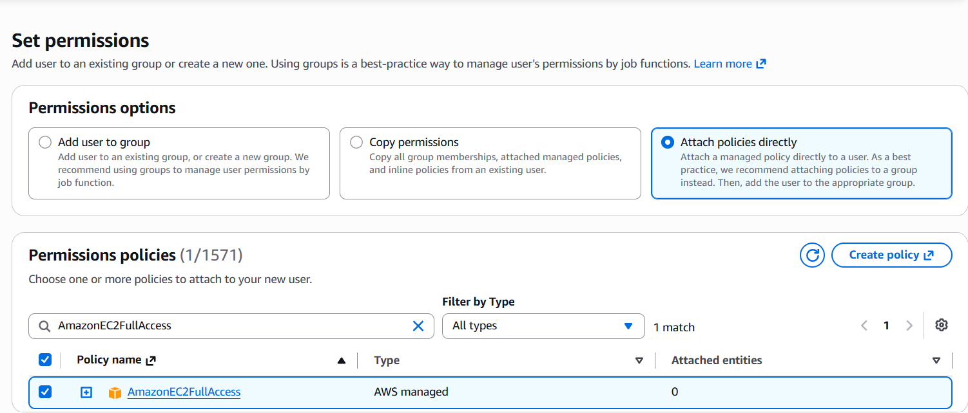
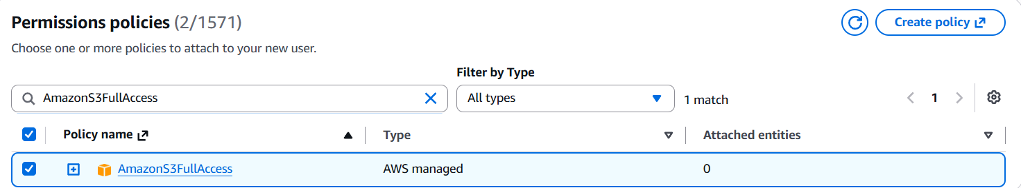
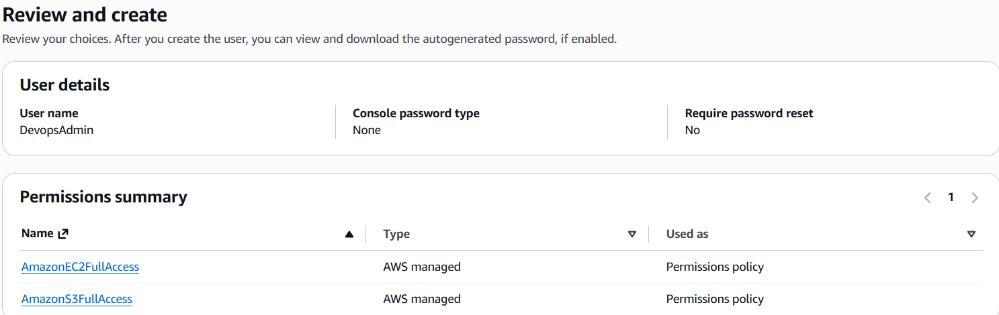
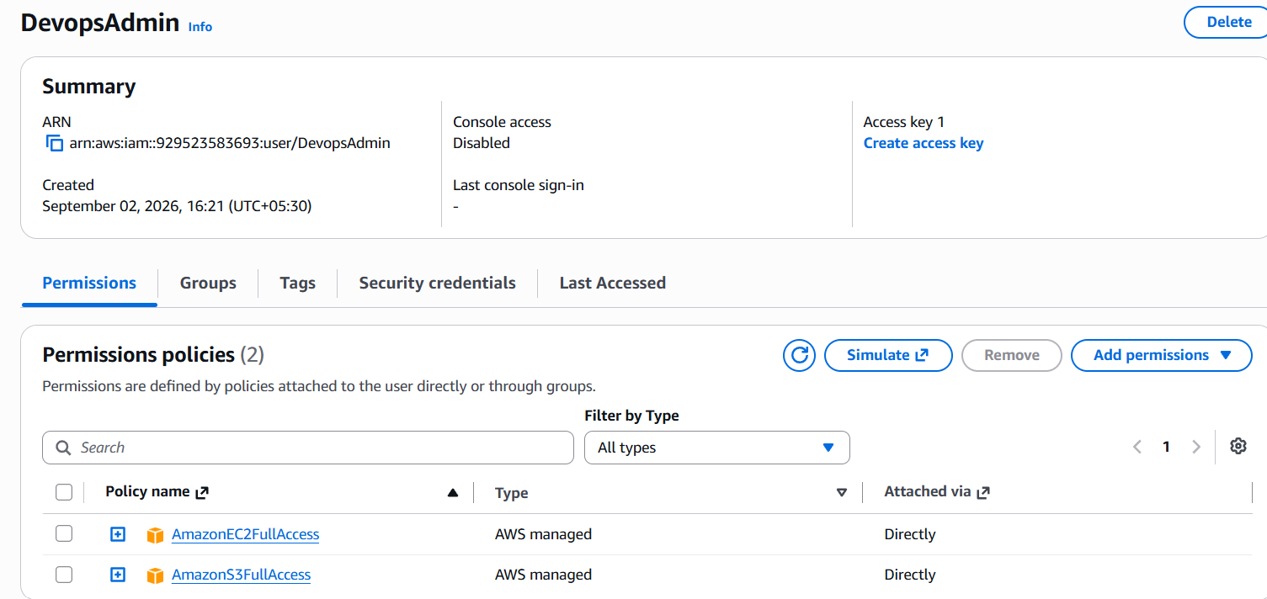

2: Create one group in IAM and assign read access for EC2.
Goal
We want:
EC2-ReadOnly-Group
│
└── AmazonEC2ReadOnlyAccess

Steps to remember
1. Open IAM
AWS Console → IAM → User groups → Create group
2. Create group
Group name → EC2-ReadOnly-Group
3. Add users
Leave users unchecked for now.
Why?
Because Task 3 will add the Devops user.
4. Attach policy
Select:
AmazonEC2ReadOnlyAccess
5. Create group
Click:
Create group
6. Verify
You should see:
EC2-ReadOnly-Group
│
└── AmazonEC2ReadOnlyAccess

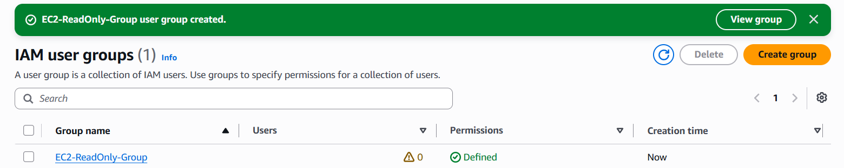

3: Create a new user named "DevOps" and add to the group created in task 2
Objective
We want to achieve:
Devops User
↓
EC2-ReadOnly-Group
↓
AmazonEC2ReadOnlyAccess
The important concept is: we will NOT attach the EC2 policy directly to Devops.
Note for your revision
- Go to IAM → Users → Create user
- Username → Devops
- Choose Add user to group
- Select EC2-ReadOnly-Group
- Create user
- Verify:
  - Devops → Permissions
  - AmazonEC2ReadOnlyAccess
  - Attached via: EC2-ReadOnly-Group

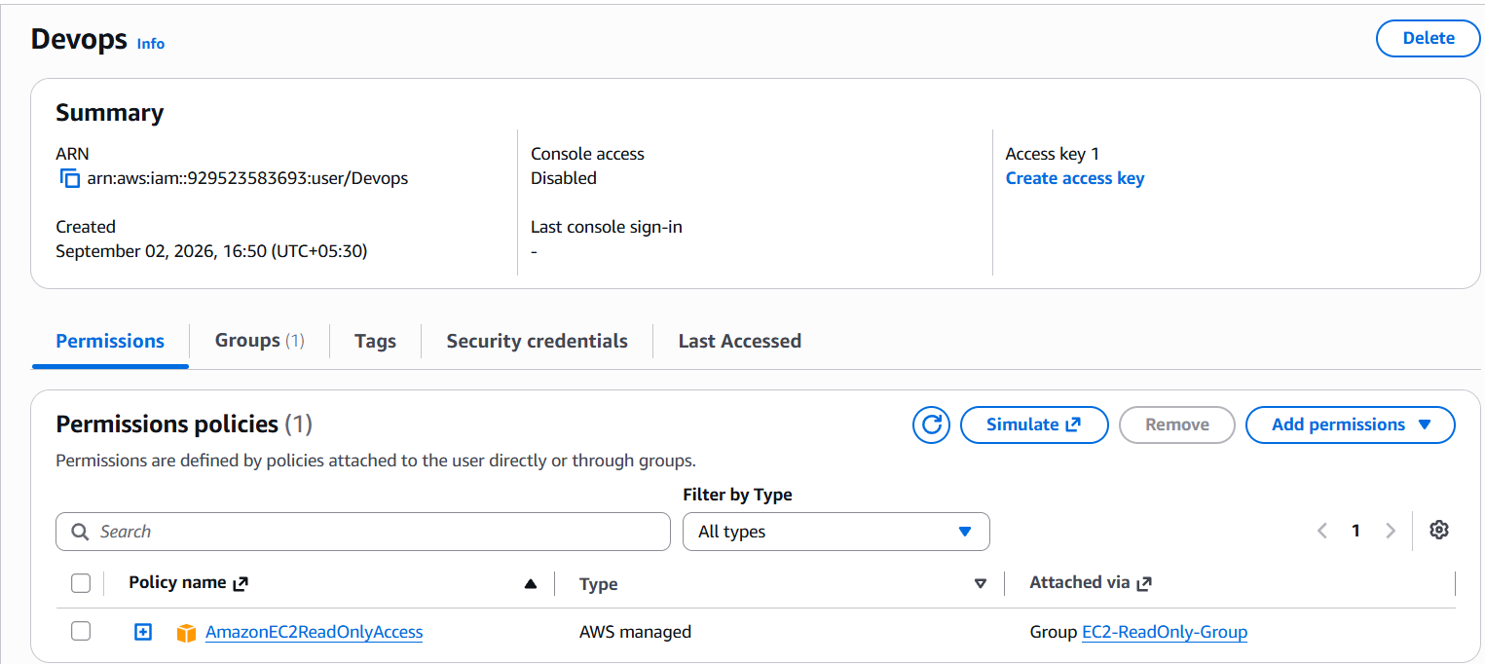

4: Write a bash script to create an IAM user with VPC full access.
Script flow
1. Define username
2. Create IAM user
3. Attach VPC policy
4. Print confirmation

Error Access denied:
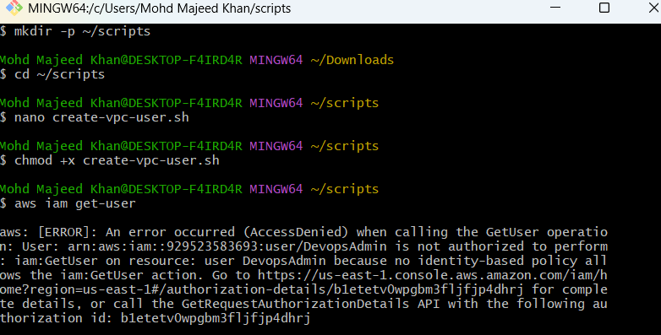
Our DevopsAdmin currently has only:
DevopsAdmin
├── AmazonEC2FullAccess
└── AmazonS3FullAccess
Those policies do not give IAM permissions.
So:
EC2 permissions ≠ IAM permissions
S3 permissions ≠ IAM permissions
Then give fullacess permission:
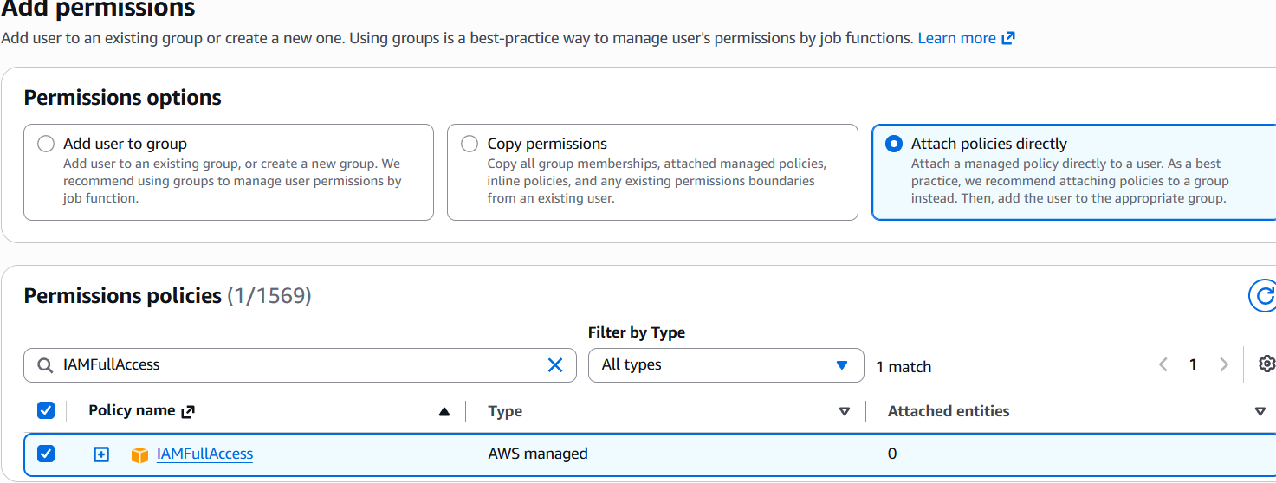
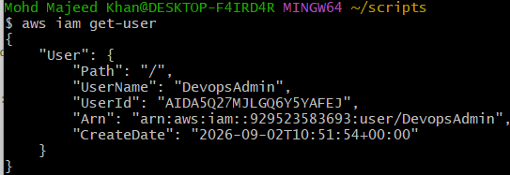
Run the Bash script:
~/scripts
./create-vpc-user.sh

- Create user:
aws iam create-user --user-name "$USER_NAME"

- Attach policy:
aws iam attach-user-policy \
--user-name "$USER_NAME" \
--policy-arn arn:aws:iam::aws:policy/AmazonVPCFullAccess

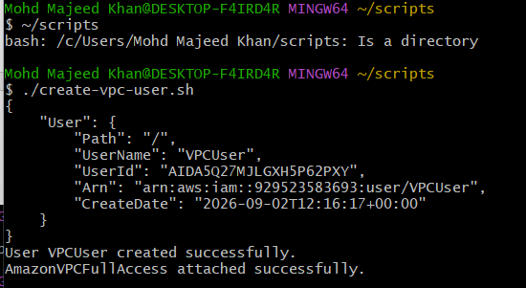

5: Create an IAM policy to allow EC2 access for a specific user in specific regions only.
Objective:
We will create a custom IAM policy that allows a specific user to use EC2 only in selected AWS Regions.
For practice, let's allow:
us-east-1 ✅
us-west-2 ✅
ap-south-1 ❌
We'll attach this policy to VPCUser.

Final setup
VPCUser
│
├── AmazonVPCFullAccess
│
└── EC2-Region-Limited-Policy
│
├── us-east-1 ✅
├── us-west-2 ✅
└── ap-south-1 ❌
The important IAM concept here is:
aws:RequestedRegion lets us restrict AWS API requests to specific Regions.

- We're going to create our own customer managed policy.
The flow is:
IAM
↓
Policies
↓
Create policy
↓
Custom JSON policy

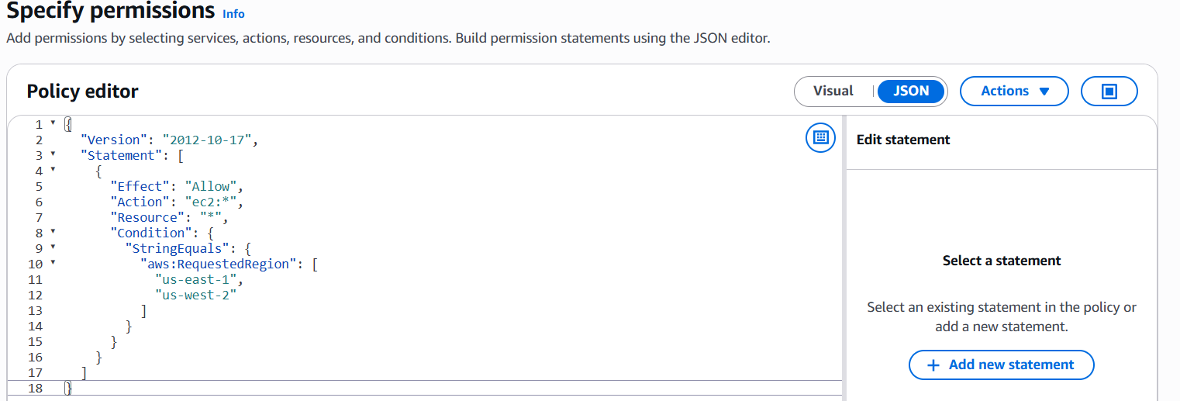
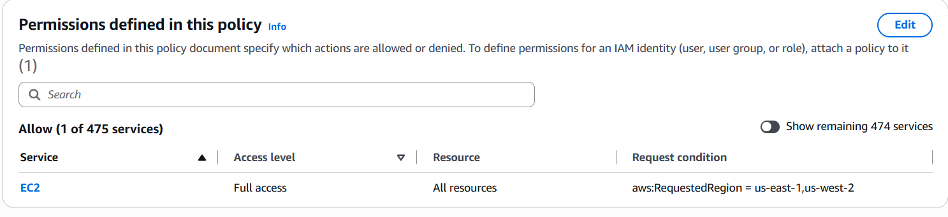
policy has been successfully created.

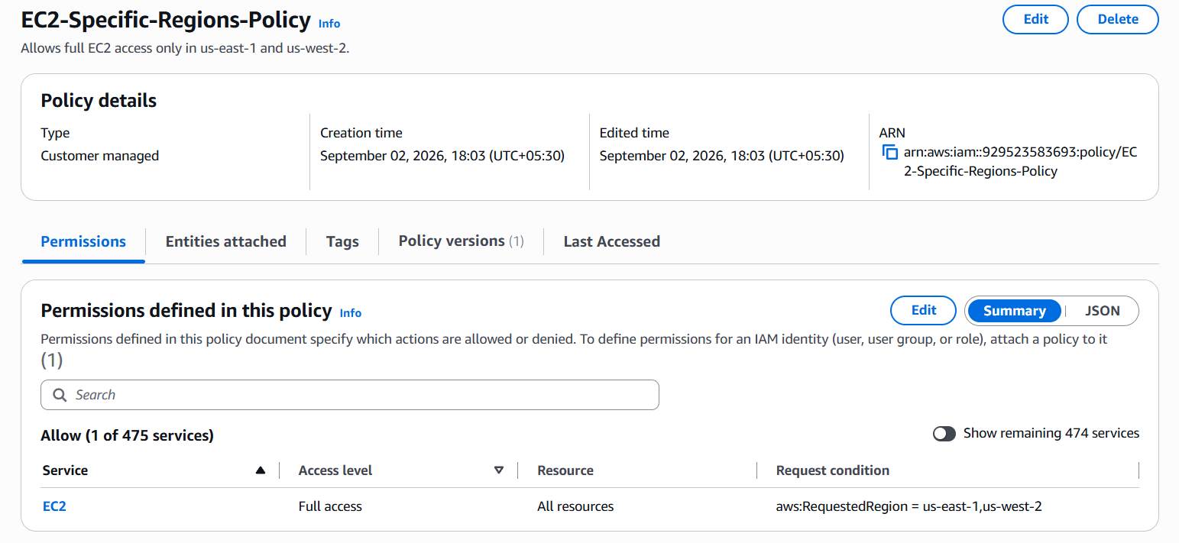

Next step — Attach it to VPCUser
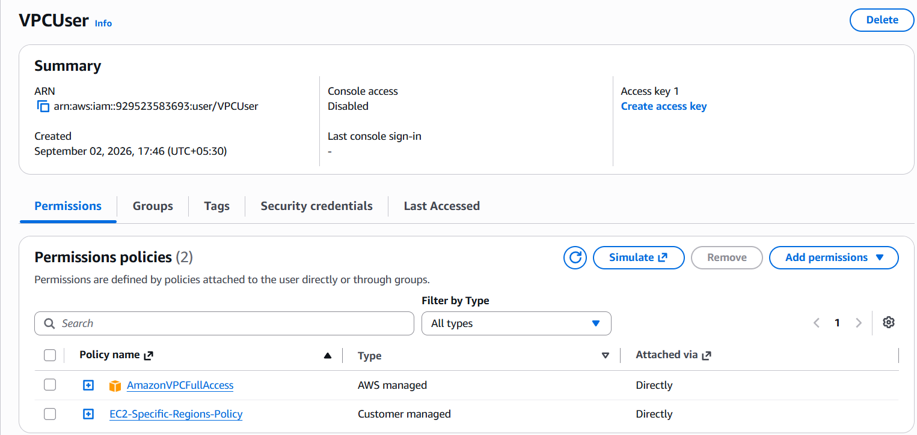
The important part is:
"Condition": {
"StringEquals": {
"aws:RequestedRegion": [
"us-east-1",
"us-west-2"
]
}
}

6: We have two accounts: Account A and Account B. Account A user should access an S3 bucket in Account B. (Collaborate with a team member and execute this. This is mostly asked in every interview.)
Important: Cross-account = Identity policy + Resource policy
{
"Version": "2012-10-17",
"Statement": [
{
"Effect": "Allow",
"Action": [
"s3:ListBucket",
"s3:GetObject"
],
"Resource": [
"arn:aws:s3:::majeed-cross-account-demo-2026",
"arn:aws:s3:::majeed-cross-account-demo-2026/*"
]
}
]
}
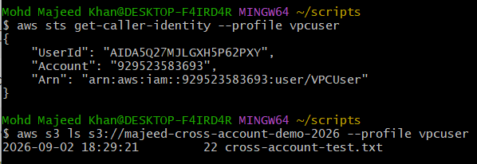

Objective
Allow Account A to access an S3 bucket owned by Account B using IAM permissions and an S3 bucket policy.

1. Created S3 Bucket in Account B
In my friend's AWS account (Account B), an S3 bucket was created:
majeed-cross-account-demo-2026
A test file/object was uploaded to the bucket.

2. Created IAM User in Account A
In my AWS account (Account A), an IAM user was created:
Devops
This user was used to access the S3 bucket from the other AWS account.

3. Configured AWS CLI
I configured an AWS CLI profile for the IAM user:
aws configure --profile vpcuser
Then verified which AWS account/user the profile belongs to:
aws sts get-caller-identity --profile vpcuser
This confirmed that the CLI was authenticated as the intended IAM user in Account A.

4. Added Permission in Account A
The IAM user was given the required S3 permissions.
For example:
{
"Effect": "Allow",
"Action": [
"s3:ListBucket",
"s3:GetObject"
],
"Resource": [
"arn:aws:s3:::majeed-cross-account-demo-2026",
"arn:aws:s3:::majeed-cross-account-demo-2026/*"
]
}
Important: Cross-account access requires permission on both sides:
Account A
IAM User Policy
+
Account B
S3 Bucket Policy

5. Added Bucket Policy in Account B
My friend added a bucket policy to the S3 bucket in Account B.
The bucket policy allowed the IAM user from Account A to access the bucket.
The important part was the cross-account principal:
"Principal": {
"AWS": "arn:aws:iam::ACCOUNT-A-ID:user/Devops"
}
And the required actions:
s3:ListBucket
s3:GetObject

6. Tested Cross-Account Access
From my computer, I tested access using the configured AWS CLI profile:
aws s3 ls s3://majeed-cross-account-demo-2026 --profile vpcuser
The bucket contents were successfully displayed.
We also verified that the object could be accessed.

Simple Architecture
ACCOUNT A ACCOUNT B
┌─────────────────┐ ┌────────────────────┐
│ IAM User │ │ S3 Bucket │
│ Devops │ │ │
│ │ │ majeed-cross- │
│ AWS CLI │ ───────────► │ account-demo-2026 │
│ vpcuser profile │ │ │
└─────────────────┘ └────────────────────┘
│ │
│ IAM Policy │ Bucket Policy
│ Allow S3 actions │ Allow Account A
└────────────── Both required ─────┘

For task 6 Interview Answer
If the interviewer asks "How did you implement cross-account S3 access?", you can say:
"I implemented cross-account S3 access between two AWS accounts. The S3 bucket was created in Account B, while an IAM user named Devops was created in Account A. I configured AWS CLI with a separate profile and verified the identity using aws sts get-caller-identity. I then configured the required S3 permissions for the IAM user and added an S3 bucket policy in Account B that trusted the IAM user from Account A. Finally, I tested the configuration using aws s3 ls with the configured profile and successfully accessed the bucket."

